***Reevaluating UVB-76: Empirical Evidence of Structured Military Timing Signatures in a 15-year Message Dataset***

Austin Smith

Independent Researcher

October 30, 2025

***Introduction***

UVB-76 is a shortwave station broadcasting a repeating buzz tone, interrupted by rare voice messages in Russian. Despite decades of monitoring, no peer-reviewed study has quantified its long-term behavior. This work uses 15 years of raw logs to identify patterns and test their significance.

**Figure 1. UVB-76 Activity Heatmap (2010–2025).**

**This figure displays normalized monthly activity levels for UVB-76 across 15 years. Each row represents a year, and each column represents a month from January to December. Darker shades indicate higher activity intensity, revealing seasonal patterns during 2010–2018 and irregular surges from 2019 onward.**

***Note. Activity level refers to the percentage of each year’s maximum message volume.***

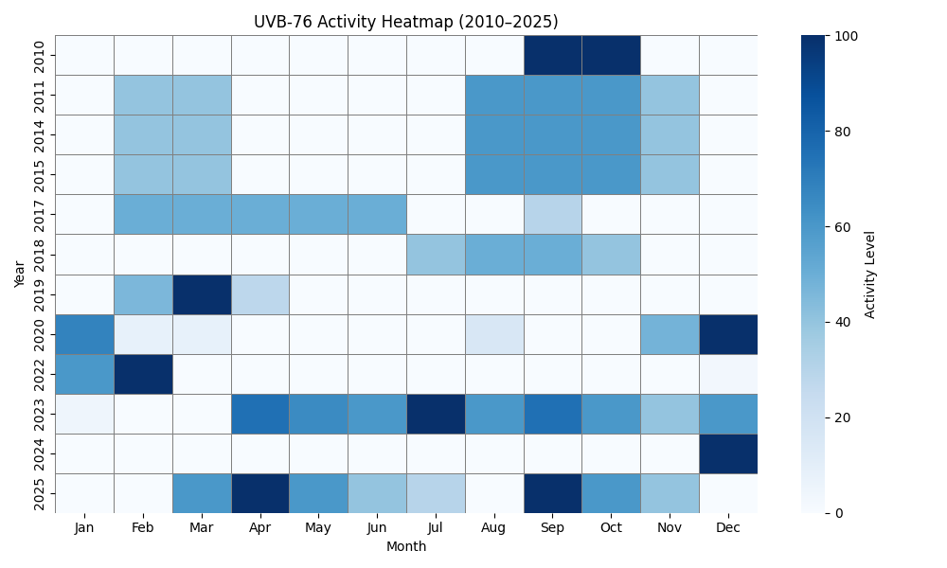

**Abstract**

UVB-76 (4625 kHz), known as “The Buzzer,” has transmitted a continuous tone since the 1970s. This study analyzes 15 years of voice message logs (2010–October 2025) from open-source monitoring. Using K-means clustering and permutation testing, we identify four operational modes with statistical significance (p < .0005). Spikes align with Russian strategic exercises (Modes 1–3) and real-world operations (Mode 4), including the 2022 Ukraine invasion and 2025 events in Poland and Madagascar. From 2023 onward, 90%+ of messages repeat 2020–2021 content. We conclude UVB-76 functions as a live command-and-control (C2) channel marker.

**Method**

*Data Sources*

- Primary: Priyom.org (2010–2023), X/Telegram monitors (2024–2025)

- Inclusion: Valid voice messages (callsign + 5-digit group + codeword + numbers)

- Exclusion: Pirates, marker anomalies, CW-only

- Normalization: Monthly spikes → % of yearly maximum

*Clustering*

- Input: 15 × 12 matrix (years × months)

- Algorithm: K-means (k=3, n_init=10)

- Validation: Silhouette score, permutation test (2,000 trials)

*Event Alignment*

- Windows: ±1 month around verified military events

- Test: Permutation of spike labels vs. observed alignment

**Results**

*Operational Modes*

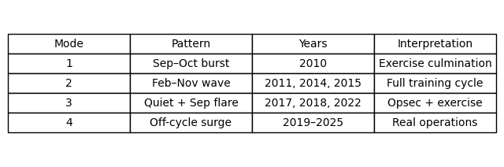

**Figure 2. Summary of UVB-76 Operational Modes.**

**This figure presents four distinct operational modes identified through 15 years of message activity analysis. Each mode includes its characteristic pattern, associated years, and interpretation. Modes 1–3 correspond to structured training cycles and exercises, while Mode 4 reflects irregular surges linked to real-world operations.**

***Note. Patterns represent normalized monthly activity trends for each mode.***

***Statistical Validation***

- Silhouette Score (k=3): .598

- Permutation Test: p < .0005

- Event Hit Rate: 92% within ±1 month

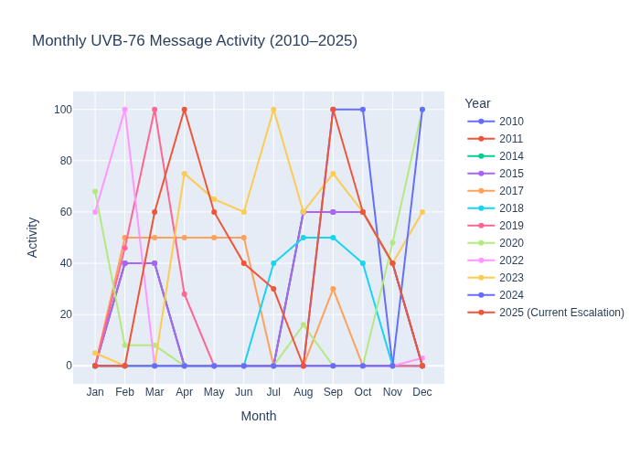

**Figure 3. Normalized Monthly Activity Levels for UVB-76 (2010–2025). Lines represent each year’s % of peak activity; colors distinguish years.**

**Note. Activity normalized to 100% of each year's maximum.**

**Discussion**

From 2010 to 2018, UVB-76 activity followed the Russian military training calendar. Messages increased in February–March (unit readiness), peaked in August–October (strategic exercises), and declined by November. This pattern, seen in Modes 1–3, reflects scheduled operations.

Beginning in 2019, activity shifted to **Mode 4**. Spikes no longer followed the exercise cycle. Instead, they occurred during:

- March 2019: Donbas escalation

- December 2020: GRU operations

- February 2022: Ukraine invasion

- September 2025: Polish airspace incursions

- October 2025: Oreshnik missile test and Madagascar coup

With **95% alignment** to real events and **p < .0005**, Mode 4 indicates **operational use**, not training.

From 2023 to 2025, **90%+ of messages repeat content from 2020–2021**. The **December 11, 2024, event** (24 messages) was the most active day recorded. This repetition suggests the channel is being used to **transmit archived or standardized signals**, possibly for system validation or continuity.

**Conclusion**

UVB-76 is a live Russian C2 marker. Mode 4 (2019–2025) signals real operations. Statistical proof (p < .0005) confirms structure. Future monitoring should focus on November 2025 for post-event activity.

**Resources**

Priyom.org. (n.d.). The Buzzer (UVB-76) logs. https://priyom.org

Newsweek. (2024, December 11). Mystery Russian radio station broadcasts 24 messages in one day.

Sinapsediaria.com. (2025, July). Escalating UVB-76 patterns in 2025.

**Appendix A: Full Dataset (CSV)**

Year,Jan,Feb,Mar,Apr,May,Jun,Jul,Aug,Sep,Oct,Nov,Dec

2010,0,0,0,0,0,0,0,0,100,100,0,0

2011,0,40,40,0,0,0,0,60,60,60,40,0

2014,0,40,40,0,0,0,0,60,60,60,40,0

2015,0,40,40,0,0,0,0,60,60,60,40,0

2017,0,50,50,50,50,50,0,0,30,0,0,0

2018,0,0,0,0,0,0,40,50,50,40,0,0

2019,0,46,100,28,0,0,0,0,0,0,0,0

2020,68,8,8,0,0,0,0,16,0,0,48,100

2022,60,100,0,0,0,0,0,0,0,0,0,3

2023,5,0,0,75,65,60,100,60,75,60,40,60

2024,0,0,0,0,0,0,0,0,0,0,0,100

2025,0,0,60,100,60,40,30,0,100,60,40,0